**PRE- MOCK SET I EXAMINATIONS, 2024**

**PRIMARY SEVEN SCIENCE**

**Duration: 2 Hours 15 Minutes**

**NAME: ______________________________________________ STREAM: _________**

INDEX NO.

EMIS NO.

**SECTION A**

1. Name the main source of heat and light in the environment.

………………………………………………………………………………………………….

1. Why are mushrooms not able to make their own food?

……………………………………………………………………………….……………….

1. State the function of red blood cells in the human body.

……………………………………………………………………………….……………….

1. State one function of wax found in the human ear.

……………………………………………………………………………….……………….

1. What is the best way a P.7 candidate can protect himself or herself against HIV/AIDS?

……………………………………………………………………………….……………….

1. Mention one example of a cereal crop.

………………………………………………………………………………………………….

1. Why do earthworms come out of soil immediately after it has rained?

……………………………………………………………………………….……………….

1. State any one function of ovaries in the human body.

…………………………………………………………………………………………………

1. How does paraffin move up the wick of a lantern?

……………………………………………………………………………….……………….

1. State one way a person acquires natural immunity.

……………………………………………………………………………….……………….

1. State any one factor that affects the pitch of sound.

……………………………………………………………………………….……………….

The diagram below is of an item used on a dairy farm. Use it to answer questions 12 and 13.

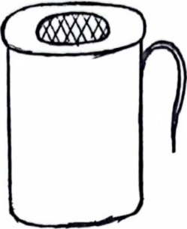

1. Name the item shown above.

……………………………………………………………………………….………………

.

1. What is the importance of the above item on a dairy farm?

……………………………………………………………………………….……………….

1. Give one example of swimming birds.

………………………...……………………………………………………….……………….

1. How is a fuse important in an electric circuit?

……………………………………………………………………………….……………….

1. Why is it not good to pour paraffin in a pit latrine?

……………………………………………………………………………….……………….

1. Define the term "mass".

………………………………………………………………………………………………..

1. How are stem tubers like white yams propagated?

…………………………………………………………………………………………….….

1. How can poultry diseases be controlled on a farm?

…………………………………………………………………………………………….….

1. Why do some flowers have brightly coloured petals?

…………………………………………………………………………………………….….

1. Identify the food deficiency disease that is caused by lack of vitamin C in the body.

……………………………………………………………………………………….…….....

The diagram, below shows a type of roots in some plants. Use it to answer questions 22 and 23.

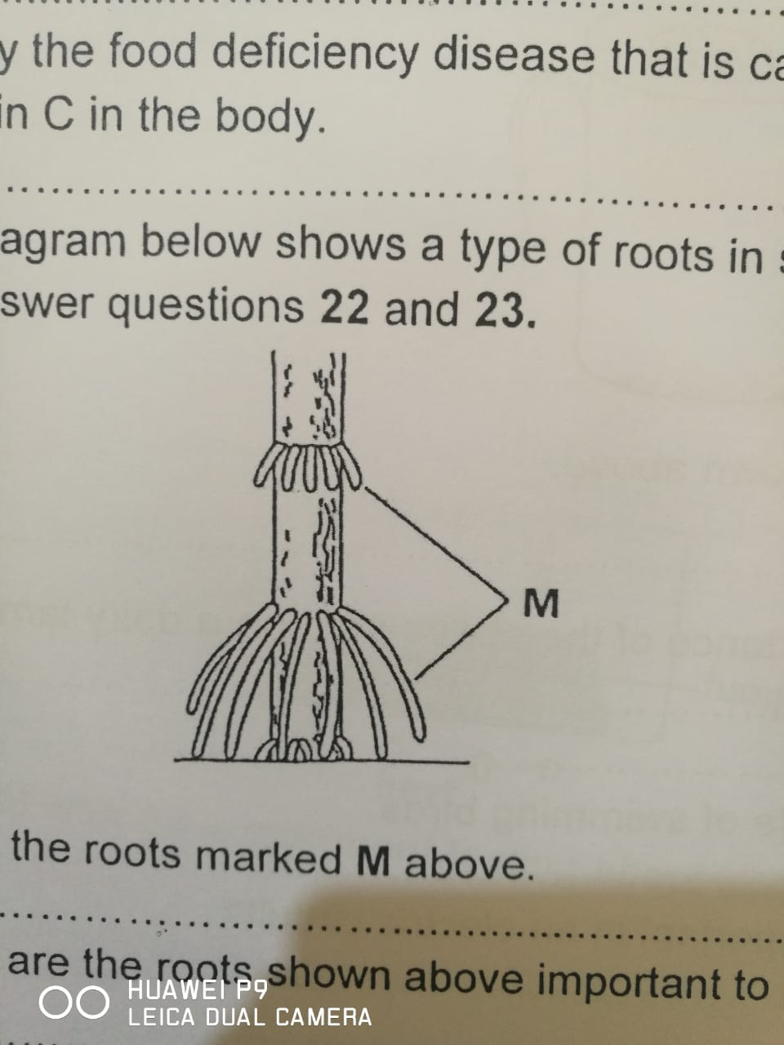

1. Name the roots marked **M** above.

……………………………………………………………………………………….……….

1. How are the roots shown above important to plants?

………………………………………………………………………………………….…….

1. Mention any one use of magnets in our daily life ………………………………………………………………………………………………..
2. How are mosquitoes dangerous to people?

…………………………………………………………………………………………………

………………………………………………………………………………….…………….

1. How are birds of prey adapted to their mode of feeding?

…………………………………………………………………………………….………….

1. How is the breathing of a tadpole similar to that of a tilapia?

……………………………………………………………………………….……………….

1. Give a reason why melting is called a physical change?

……………………………………………………………………………….……………….

1. Write down any one method used to extract honey from honey combs.

…………………………………………………………………………………….………….

1. Why is syphilis called an infectious disease?

…………………………………………………………………………………………….….

……………………………………………………………………………………………….

The diagram below shows an experiment about soil. Use it to answer questions 31 and 32.

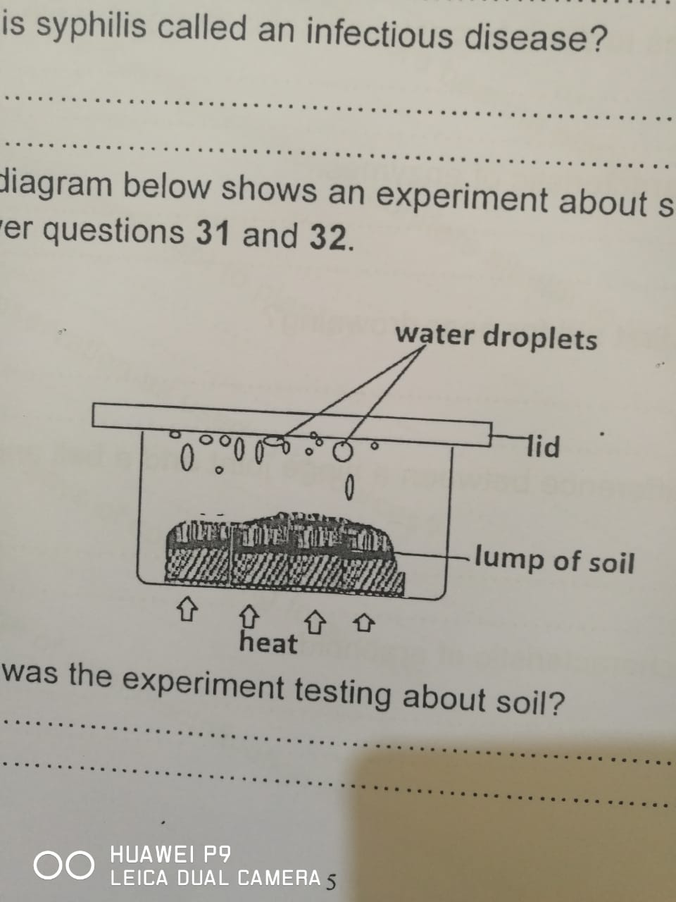

1. What was the experiment testing about soil?

………………………………………………………………………………………….…….

1. By what process are the water droplets formed on the lid as shown above?

……………………………………………………………………………………………….

1. State the energy change that takes place in a dry cell when it is in use.

……..…………….………………………………………………………………………….….

1. State any one method used to administer vaccines to people.

………………………………………………………………………………………………….

1. Why do electric wires appear tight on a cold day?

………………………………………………………………………………………………..

1. What happens to the intercostal muscles during breathing in?

…………………………………………………………………………………………….….

1. State one characteristic of enzymes?

………………………………………………………………………………………….…….

1. What is the first aid for near drowning?

……………………………………………………………………………………………….

………………………………………………………………………………………………..

1. State one difference between a hinge joint and a ball and socket joint.

…………………………………………….………………………………………………….

1. State one characteristic of arachnids.

……………………………………….……………………………………………………….

**SECTION B (60 Marks)**

1. State the function of each of the following instruments.
2. Hygrometer ………………………………………………………………………………..

………………………………………………………………………………………………..

1. Hydrometer ……………………………………………………………………………….

……………………………………………………………………………………………….

1. Rain gauge ………………………………………………………………………………..

……………………………………………………………………………………………….

1. Barometer ………………………………………………………………………………….

………………………………………………………………………………………………..

1. a) Mention any two sexually transmitted diseases apart from HIV/AIDS.

i)……………………………………….……………………………………………………….

ii)…………………………………………………………………………………………….....

b) Which sexually transmitted disease causes blindness in babies?.

……………………………………….……………………………………………………….

c) State one effect of HIV/AIDS to a family?

……………….……………….……………….……………….……………….………………

…………………………………………………………………………………………………

1. a) What is mulching?. ………………………………………………………………………………………………………………………………………………………………………………………………………………..

b) Mention any two materials used for mulching.

(i) ……………………………………….……………………………………………………….

(ii) ……………………………………………………………………………………………….

c) State one disadvantage of mulching.

……………….……………….……………….……………….……………….………………

1. Name the second stage of the following insects in their life cycle?

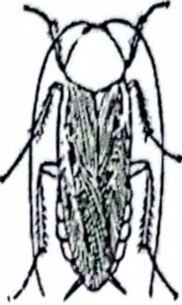

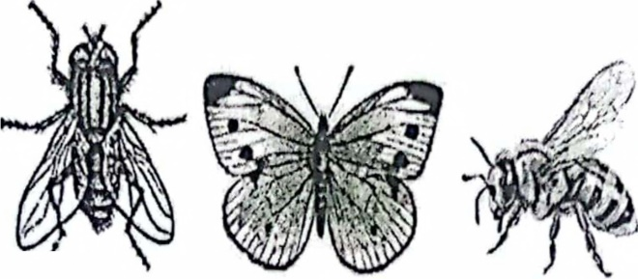

**A B C D**

1. A ……………………………………………………………………………………………….
2. B ……………………………………………………………………………………………….
3. C ……………………………………………………………………………………………….
4. D ………………………………………………………………………………………………...
5. a) Give two examples of spore bearing plants?
6. …………………………………………………………………………………………………
7. ………………………………………………………………………………………………….

b) How is the reproduction in conifers similar to that in beans?

…………….…...…………………………………………………………………………………….

………………..……………………….……………….…………………………………………....

c) How is osmosis important to plants

…………………………………………………………………………………………………………..

1. a) What is conservation as used in resources?

…………………………………………………………………….……………………………………………………………………………………………………………………………………………….

b) Mention any two ways of conserving fossil fuels.

i)…………………………………………………… ……………….………………………

ii)…………………………………………………… ……………….……………………..

c) What is the advantage of rural electrification to a country like Uganda?

………………………………………………………………………………………………..

1. a) State one way of caring for garden tools.

……………………………………………………………………………………………….

b) Draw these garden tools.

|  |  |
| --- | --- |
|  |  |
| Trowel | Garden fork |

1. Apart from digging, give one other method used to harvest root crops

………………………………………………………………………………………………

1. (a) What is energy?

……………………………………………………………………….…………………….

……………………………………………………………………….…………………….

1. Which type of mechanical energy is possessed by water in a pond?

...………………………………………………… ……………….………………………....

1. Calculate the work done by a man who pushed a load of 30000grams through a distance of 24metres. (2 marks).
2. The diagram below shows a method of making magnets. Use it to answer the questions that follow.

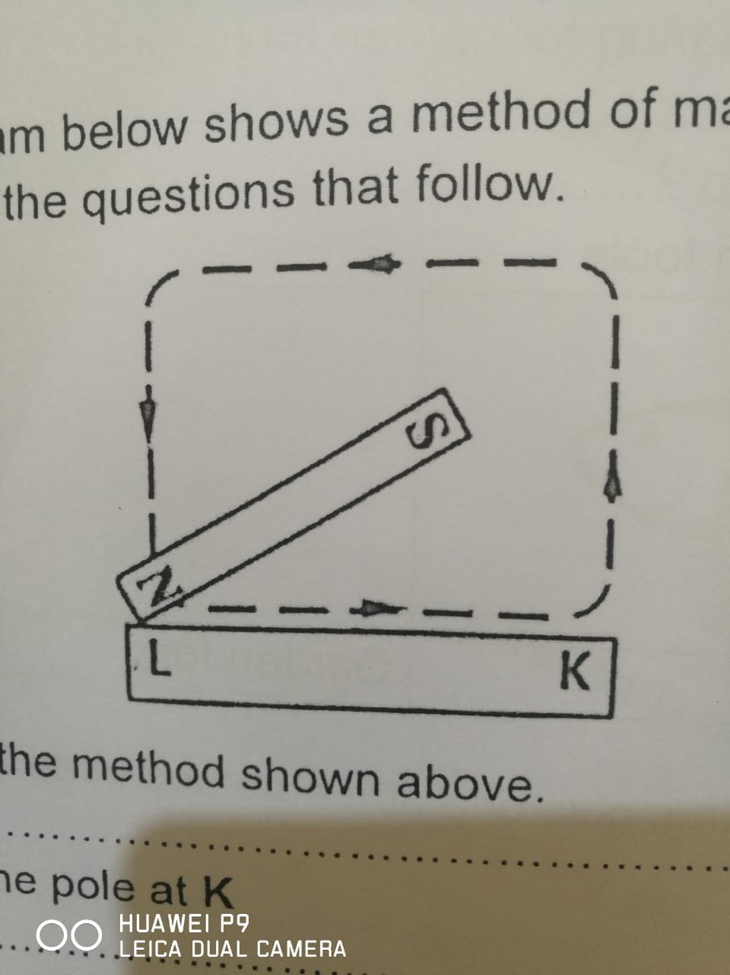

1. Identify the method shown above

..………………………………………… ……………….………………………………....

b) Name the pole at **K**.

…..………………………………………… ……………….………………………………....

c) Give two examples of magnetic materials.

i)..……………………………………………………………………….…………………….

ii) ………………………………………………………….………………………………….

1. a) Write **ORS** in full.

………………………………………………………………….……………………….....

b) Mention any one solute used to make **ORS** locally.

…………………………………………… ……………….……………………………..

c) Why should one first wash hands with clean water and soap before preparing **ORS?**

……………………………………………………………….…………………………….

1. State the difference between dehydration and rehydration.

………………………………………………………………………………………………………………………………………………………………………………………………………………

1. a) Give two characteristics of seeds dispersed by wind.

i)…………………………………………… ……………….……………………………..

ii)………………………………………… ……………….……………………………….

b) How is seed dispersal important in the environment?

……………………………………………………………………………………………….

c) Mention one agent of seed dispersal?

……………………………………………………………….…………………………….

1. Study the diagram below and answer the questions that follow.

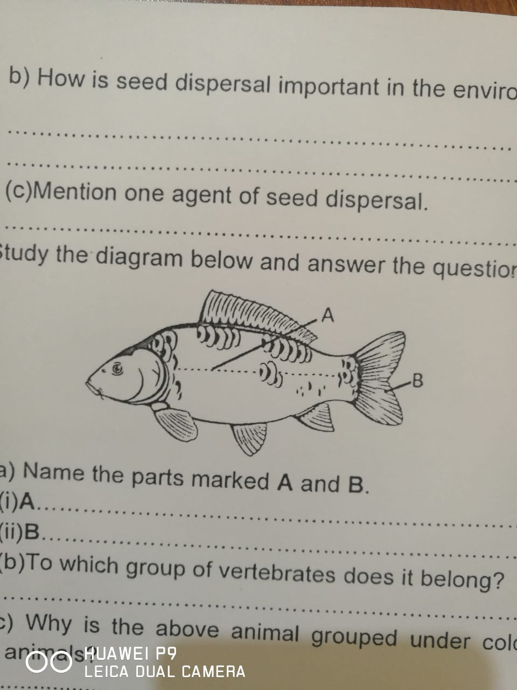

a) Name the parts marked A and B.

(i) A)…………………………………………… ……………….……………………………..

(ii) B)………………………………………… ……………….……………………………….

b) To which group of vertebrates does it belong?

……………………………………………………………………………………………….

c) Why is the above animal grouped under cold blooded animals?.

……………………………………………………………………………………………….

1. a) Which term is used to refer to people who need special care in terms of diet?

…………………………………………………………………………………………………….

1. Write down two ways of caring for the people mentioned above.
2. …………………………………………………………………………………………………
3. ………………………………………………………………………………………………..
4. What do you understand by the term "convalescent?".

…………………………………………………………………………………………………

1. a) Name one method used to make alcohol.

i)………………………………… ……………………………………………………………

ii)……………………………………………………………………………………………..

b) Why is yeast used during fermentation of sugar?

………………………………………………………………………………………………

c) State any two effects of alcoholism to an individual

(i) …………………………………………………………………………………………….

(ii) …………………………………………………………………………………………….

1. Rearrange the following sentences in the correct order.

• Pour water into the mixture to dissolve the salt.

• Use a magnet to remove iron filings.

• Heat the solution until the water evaporates completely.

• Filter the mixture to remove sand

Correct order

1. ………………………………………………………………………………………………….
2. ………………………………………………………………………………………………….
3. …………………………………………………………………………………………………
4. ………………………………………………………………………………………………….

**\*\*\*END\*\*\***